Приклад 1.
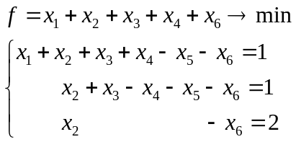

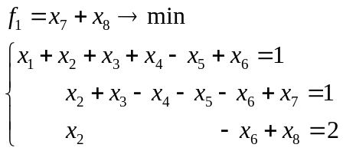
X1=1-x2-x3-x4+x5+x6
F=1+x5+2x6

 | X2 | X3 | X4 | X5 | X6 | B
X1 | 1 | 1 | 1 | -1 | -1 | 1
X7 | 1 | 1 | -1 | -1 | -1 | 1
X8 | 1 | 0 | 0 | 0 | -1 | 2
F | 0 | 0 | 0 | -1 | -2 | 1
F1 | 2 | 1 | -1 | -1 | -2 | 3

 | X3 | X4 | X5 | X6 | B
X1 | 0 | 2 | 0 | 0 | 0
X2 | 1 | -1 | -1 | -1 | 1
X8 | -1 | 1 | 1 | 0 | 1
F | 0 | 0 | -1 | -2 | 1
F1 | -1 | 1 | 1 | 0 | 1

 | X3 | X4 | X6 | B
X1 | 0 | 2 | 0 | 0
X2 | 0 | 0 | -1 | 2
X5 | -1 | 1 | 0 | 1
F | -1 | 1 | -2 | 2

 | X3 | X1 | X6 | B
X4 | 0 | ½ | 0 | 0
X2 | 0 | 0 | -1 | 2
X5 | -1 | -1/2 | 0 | 1
F | -1 | -1/2 | -2 | 2

X=(0;2;0;0;1;0)

Приклад 2.
.
2. 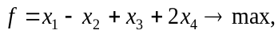
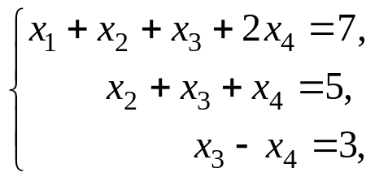

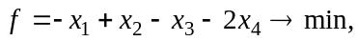
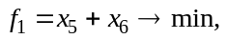

Приклад 3
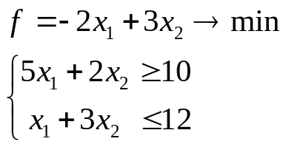

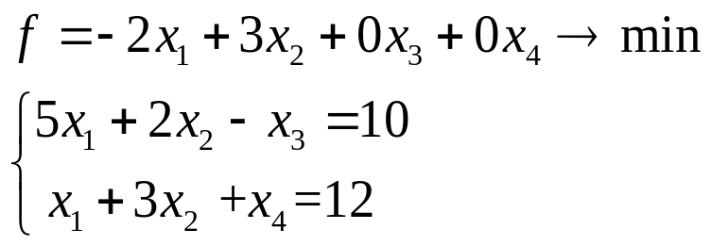

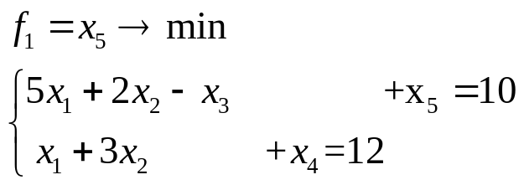

 | X1 | X2 | X3 | B
X5 | 5 | 2 | -1 | 10
X4 | 1 | 3 | 0 | 12
F | 2 | -3 | 0 | 0
F1 | 5 | 2 | -1 | 10

Приклад 4

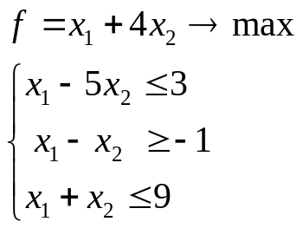

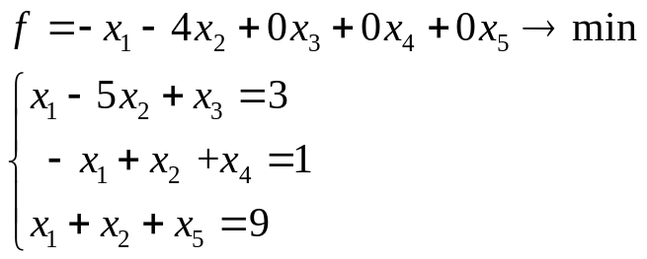

 | X1 | X2 | B
X3 | 1 | -5 | 3
X4 | -1 | 1 | 1
X5 | 1 | 1 | 9
F | 1 | 4 | 0

Приклад 3

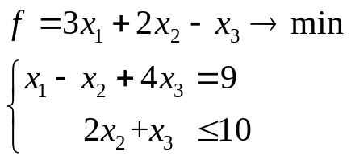

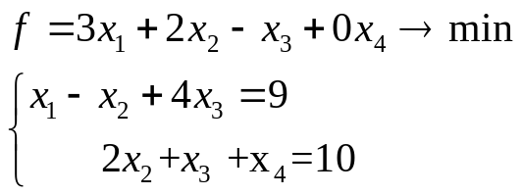

X1=9+x2-4x3
F=3*(9+x2-4x3)-2x2-x3=27+4x2-13x3

 | X2 | X3 | B
X1 | -1 | 4 | 9
X4 | 2 | 1 | 10
F | -4 | 13 | 27

Домашнє завдання

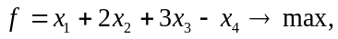
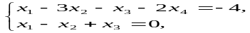

. 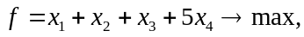
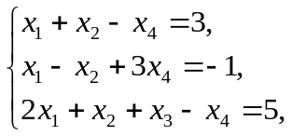

1)
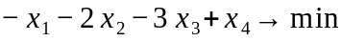
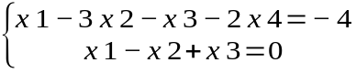

Зведемо до канонічного вигляду, поділимо на (-2) першу умову

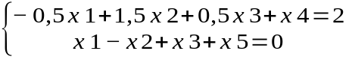

x4= 2 + 0,5x1 - 1,5x2 - 0,5x3
F = - 0,5x1 - 3,5x2 - 3,5x3 + 2

f1 = x6 min
 | x1 | x2 | x3 | B
x4 | -0,5 | 1,5 | 0,5 | 2
x5 | 1 | -1 | 1 | 0
F | 0,5 | 3,5 | 3,5 | 2
f1 | 1 | -1 | 1 | 0

 | x5 | x2 | x3 | B
x4 | 0,5 | 1 | 1 | 2
x1 | 1 | -1 | 1 | 0
F | -0,5 | 4 | 3 | 2
f1 | -1 | 0 | 0 | 0

 | x2 | x3 | B
x4 | 1 | 1 | 2
x1 | -1 | 1 | 0
F | 4 | 3 | 2
f1 | 0 | 0 | 0

 | x2 | x3 | B
x4 | 1 | 1 | 2
x1 | -1 | 1 | 0
F | 4 | 3 | 2

 | x4 | x3 | B
x2 | 1 | 1 | 2
x1 | 1 | 2 | 2
F | -4 | -1 | -6

X* = (2 2 0 0)
F(X*) = -6
2)
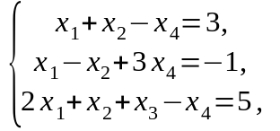
f = - x1 - x2 – x3 - 5x4 ------ min

x1 + x2 – x4 + x5 = 3
-x1+x2 – 3x4 + x6 = 1
2x1 + x2 + x3 – x4 = 5
f1 = x5 + x6

x3 = 5-2x1-x2+x4
f = -x1 – x2- 5+ 2x1+ x2 – x4 + 5x4 = x1 + 4x4 – 5

 | x1 | x2 | x4 | B
x3 | 2 | 1 | -1 | 5
x5 | 1 | 1 | -1 | 3
x6 | -1 | 1 | -1 | 1
F | -1 | 0 | -4 | -5
f1 | 0 | 2 | -2 | 4

 | x1 | x6 | x4 | B
x3 | 3 | -1 | 0 | 4
x5 | 2 | -1 | 0 | 2
x2 | -1 | 1 | -1 | 1
F | -1 | 0 | -4 | -5
f1 | 2 | -2 | 0 | 2

 | x1 | x4 | B
x3 | 3 | 0 | 4
x5 | 2 | 0 | 2
x2 | -1 | -1 | 1
F | -1 | -4 | -5
f1 | 2 | 0 | 2

 | x5 | x4 | B
x3 | -1,5 | 0 | 1
x1 | 1 | 0 | 1
x2 | 0,5 | -1 | 2
F | 0,5 | -4 | -6
f1 | -1 | 0 | 0

 | x4 | B
x3 | 0 | 1
x1 | 0 | 1
x2 | -1 | 2
F | -4 | -6

X*(1,2,1,0) f(X*) = -6

